SRS _ Tic Tac Toe
JAVA based game

Team: 1. Subham singh (151220001)
2. Raunak Pathak (151220004)
3. Navneet kumar (151220006)
ECE 2nd year
NIT Delhi
Lab instructor: Mr. Utkarsh
Course instructor: Mrs. Nonita sharma

INDEX
The Document contains SRS containing descriptions about following aspects:
1. Problem description
2. Functional requirements
- Use case
3. Non-Functional requirements
4. Analysis
5. Design

Problem description :
Tic-Tac-Toe is a board-game. It has two players. Each player has an icon depicting a nought ( 0 ) or a cross ( X ). The board is divided into 3X3 squares and each square can be occupied by one icon. If three icons of same type appear in a row either vertically or horizontally or diagonally, the user of that icon will be declared winner by the system. If all the squares of the board are filled and no user is the winner then the game is declared as draw by the system. If a player quits the game, the system should allow the players to make moves alternatively or to quit.
This is the problem description of Tic-Tac-Toe. It is desired to develop a software using object - oriented analysis and design approach.
Non-functional requirements:

1. The game should be easy to use.
2. It should work on any OS (Windows, Linux Or Mac).
3. It should have very fast response time and be lag free.

Functional requirements:
1. The game should accept x or o from each player respectively
2. If any player wins it should display the winning player
3. In a case of draw, the game should display a draw message

- Use case: :

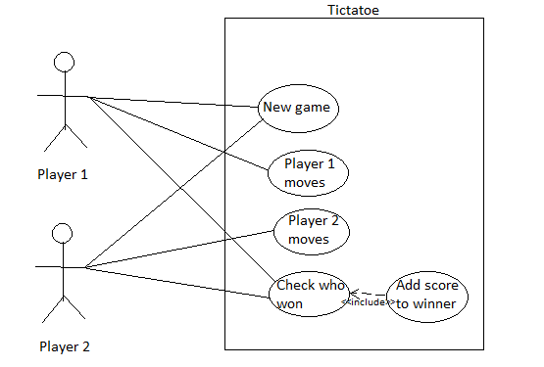

Analysis:
Starting with initial list of classes, here we prune the classes on the basis of redundancy, vagueness, irrelevancy, attributes etc.
Classes to be Pruned
- Board - Game
  - This sounds like a vague class as it conveys different meanings at different perspective. It is better to be skipped.
- Player
  - Sounds useful and also relevant to the system. So let us keep this class.
- Icon
  - Icon holds a lot of significance and hence we should decide to model this one too. In fact, the players are distinguished by the icon they are playing with. Hence our decision to model this class.
- Board
  - The whole game is played on the board. Let us model this class.
- Square
  - The Player attacks a square always and there is a heavy contest in arranging the icons on these squares. Let us keep it.
- Type
  - It refers to the group of icons. A player is declared a winner if three icon of the same 'type' occupies a row, either horizontally, vertically or diagonally. If we study the sentences closely, it would be clear that 'type' is merely an attribute of the class Icon. Obeying the modeling guidelines, let us not model this term.
- Row
  - A row in this game is actually irrelevant. What we mean here is that there is absolutely no significance to the term 'row'. What we are interested in is the square and after filling up the square, it is the pattern of occupancy, which decides the winner. Hence we shall skip the row.
- User
  - This is a redundant class as we have decided to keep a Player class.
- Winner
  - Clearly, Winner is an attribute of a Player. There is no need to model on attributes as the rules say so.
- System
  - System is another example, that conveys a lot of meanings at different perspective. What we really mean is the whole system. This is really significant and so let us keep it.
- Game
  - It refers to a play where two players compete and a winner is decided. Or maybe it ends in a draw. Then the board is flushed and the next game is started upon. Let us model this class.
- Opponent
  - This is again a redundant class as the players are differentiated by the icons they play with. We have modeled all the needed terms and hence 'Opponent' becomes redundant. Let us reject it.
Design:
Classes after Elimination
After the steps mentioned above, we are left with the following classes.
- Player
- Icon
- Board
- Square
- System
- Game
Let us go through these classes again and try to see if there is a possibility of using descriptive names. In Object Oriented Modeling, it is significant to use the correct name for a class as it should convey the right meaning.
- Player
  - Cannot be a better term to replace this term. Let us keep it.
- Icon
  - Fits the explanation. Let us not disturb it.
- Board
  - Conveys the right meaning. No need to modify.
- Square
  - An apt term to explain the role. No need to modify.
- System
  - We have just discussed about this term and it is a bit misleading. Hence it becomes imperative on our part to choose a better term. Let us replace this term with 'Game Application' or 'Game Manager'.
- Game
  - Sounds appropriate. Still, the term would cause confusion. Let us give it a different name - 'Board View'
From here, let us move on to the next section where we shall have a look at the final set of classes.
The result of this procedure is the following list of classes
Player | Square
Icon | Game Manager
Board | BoardView

